**Time Series Forcecastability**

**Forecastability:**

Forecastability is a measure of the degree to which something may be forecast with accuracy. The time series analysis it specifically relates to the ability to forecast future values of a variable based on historical data. It is a technique for the prediction of events through a sequence of time. The more regular and repeatable patterns a time series exhibits the easier it is to make accurate predictions.The formula is

**Additional sales = previous month's sales x velocity**

**forecasted sales for next month = additional sales + previous month's rate**

Apen small and Spen small are identifiable patterns, trends, or charateristics in the time series data for both variables. This implies that accurate forecasts can be made for these variables based on historical trends and patterns.

**Apen Small- Forecastability:**

The characteristics in the time series data of Apen Small that make it possible to forecast values with a reasonable degree of accuracy.

**Spen Small – Forecastability:**

Spen Small the forecastability is linked to the presence of characteristics in the time series data that make it feasible to forecast future values accurately.

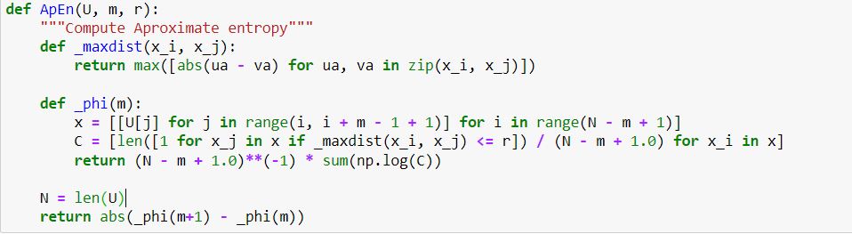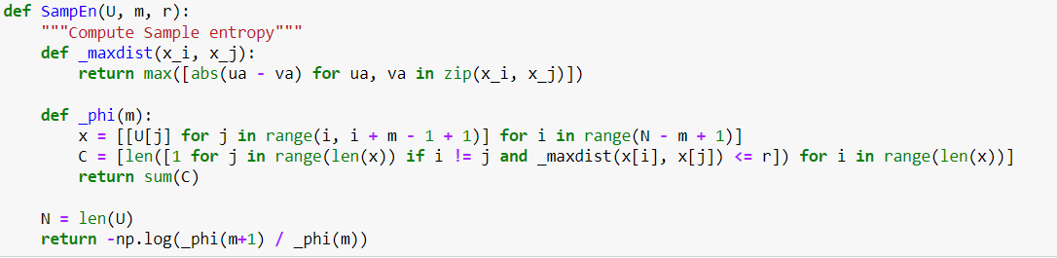

Calculating the Approximate Entropy(APEn) and Sample Entropy(sampEn) of a given time series respectively. These measures are used to quantify the complexity or irregularity of time series data.

The function takes three arguments. **U** is the time series data set. **m** is a dimension. This is the number of consecutive data points that are used to create a vector for comparison. **r** is a maximum difference between two vectors that is considered to be a match.

_maxdist function calculates the maximum distance between corresponding elements of two sequences x_i, x_j. It is used in the later calculation to measure dissimilarity between sequences.

N is the length of the input time series U. The function calculates the absolute difference between two values obtained by applying _phi to sequences m and m+1. This absolute difference is a measure of the irregularity or complexity of the time series.

Both functions are designed to quantify the complexity or irregularity of a time series by calculating Approximate Entropy(ApEn) and Sample Entropy (SampEn).

The calculations are based on the lengths and similarities of non-overlapping sequences within the time series.